DAS

A screen shot of a computer desk

Description generated with very high confidenceData Acquisition System (DAS) consists of a set of computers and electronics controlling the acquisition and storage of data collected at each instrument at SNS. The das-opi computer is the main computer and most of the work for setting up runs occur on this computer. There are two monitors for the das-opi computer towards the left side of the hutch (Figure 1). On the right side of the hutch are computers for data reduction, visualization and analysis.

das-opi:

control

das-opi:

control

NOMAD3:

analysis

NOMAD:

analysis

Figure 1. NOMAD hutch, showing the analysis and control computers.

Dashboard

The right monitor of the das-opi control computer displays the instrument dashboard (Figure 2). The dashboard contains all the information and controls a typical user will need for their experiment. A screenshot of a computer

Description generated with very high confidence

Figure 2. Dashboard general layout.

Instrument Status Display The left column (Figure 3) of the dashboard displays instrument status, including the beam power and shutter status indicators at the top. The total time and collected beam proton charge of the current run are shown in the Run Information box. The sample name, composition and other details are shown in the Sample Information box. The Proposal Information box indicates the currently selected proposal. In the Beam Information box is the status of the bandwidth choppers, including the center wavelength and frequency.

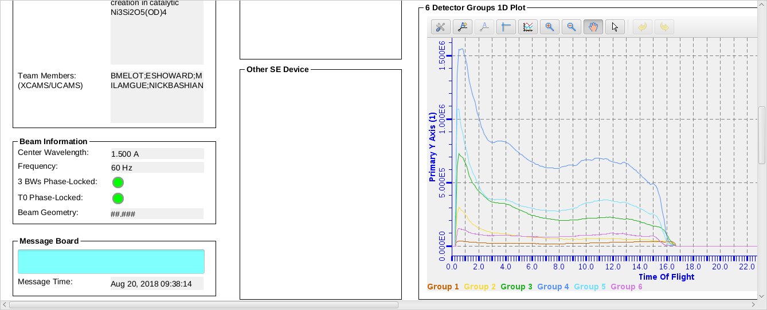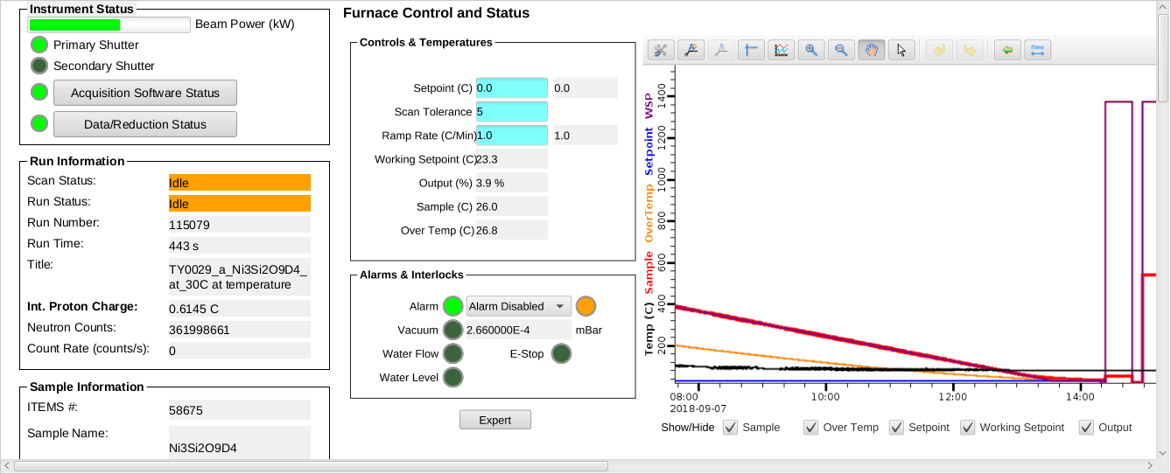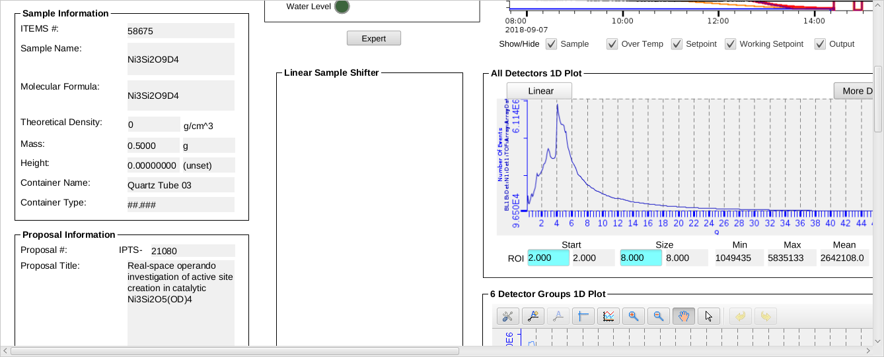

Figure 3. Instrument Status Display

Sample Environment Controls The upper center section (Figure 4) of the dashboard displays a plot of the sample temperature and sample environment controls, including the setpoint, ramp rate and tolerance. The left side of the lower center section (Figure 5) displays a couple of other sample environment controls, such as Linear Sample Shifter.

Data Plots The right side of the lower center section (underneath the temperature plot) displays the 1D plot for all detectors (Figure 5), which shows the diffraction data, summed across all detectors, as a function of d-spacing, Q or time-of-flight (tof). This is followed by the 1D plots for each of the six detector groups (Figure 5).

The right section (Figure 6) of the dashboard displays the Detector 2D Plot at the top, which shows the total counts across each detector face. The bottom plot shows the beam monitor spectrum.

Plot options are available by right-clicking in the plot area and selecting Show/Hide Graph Toolbar (Figure 7). By default the plot will autoscale in both the x- and y-axes. In order to zoom in, you must disable autoscale by clicking the Configure Settings button on the left end of the graph toolbar, going to the Axes tab, selecting the desired axis from the dropdown menu and then unchecking the Auto Scale Enabled option. Once autoscale is disabled, you may click the Rubberband Zoom button in the graph toolbar and then click and drag on the plot to zoom in. Clicking the Perform Autoscale button in the graph toolbar will zoom the plot back full.

A screenshot of a cell phone

Description generated with very high confidenceFigure 4. Center area of the dashboard, showing temperature controls at the top.

Figure 5. Center area of the dashboard, showing detectors 1D plots at the bottom.

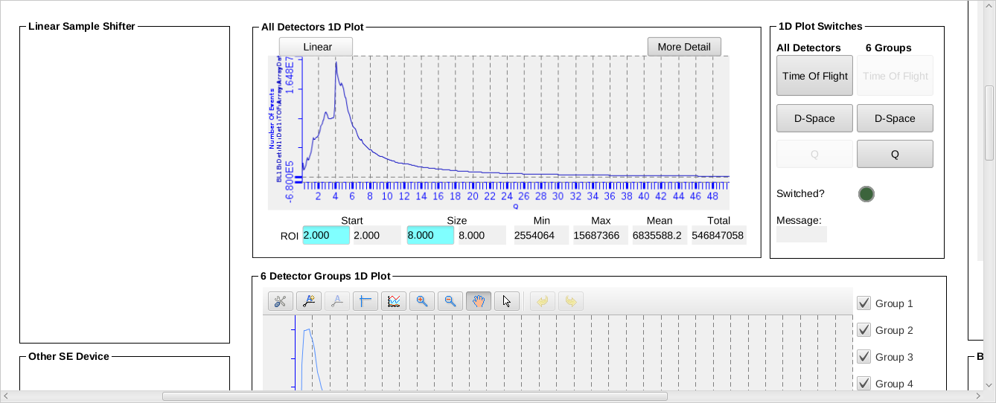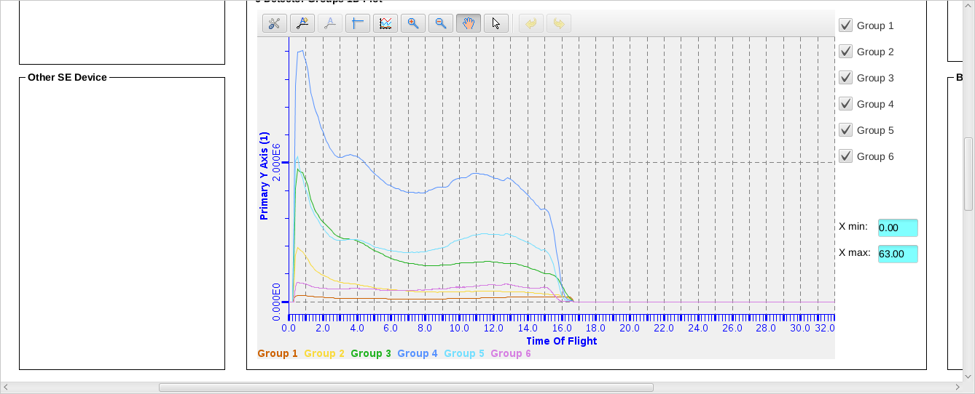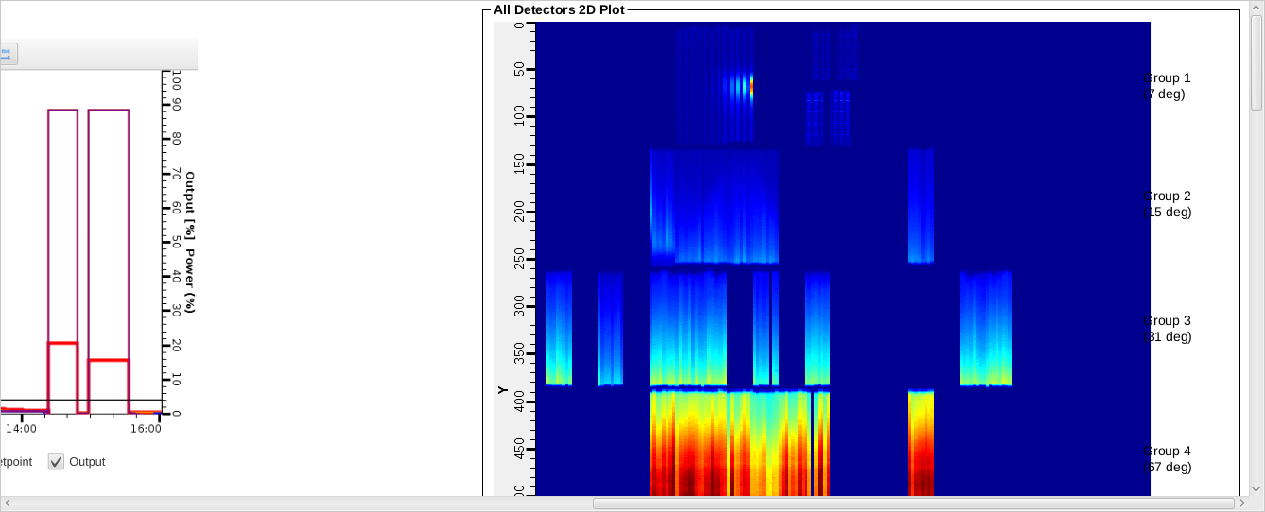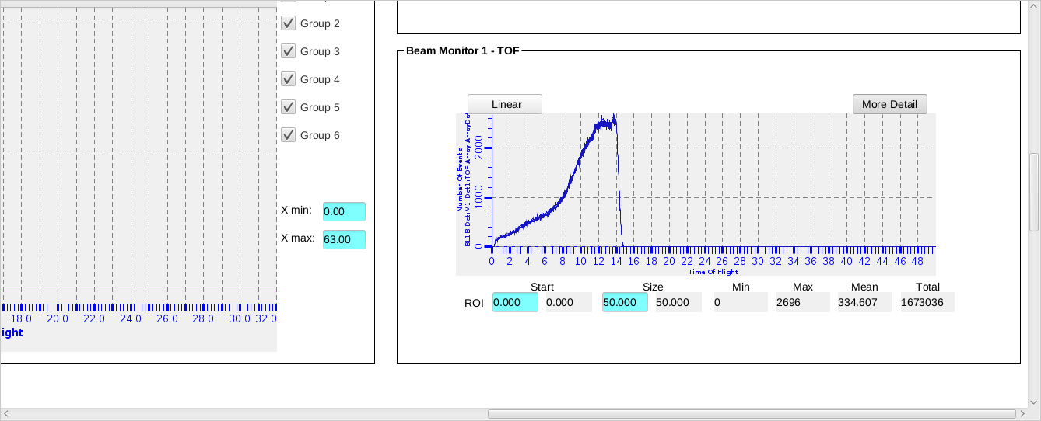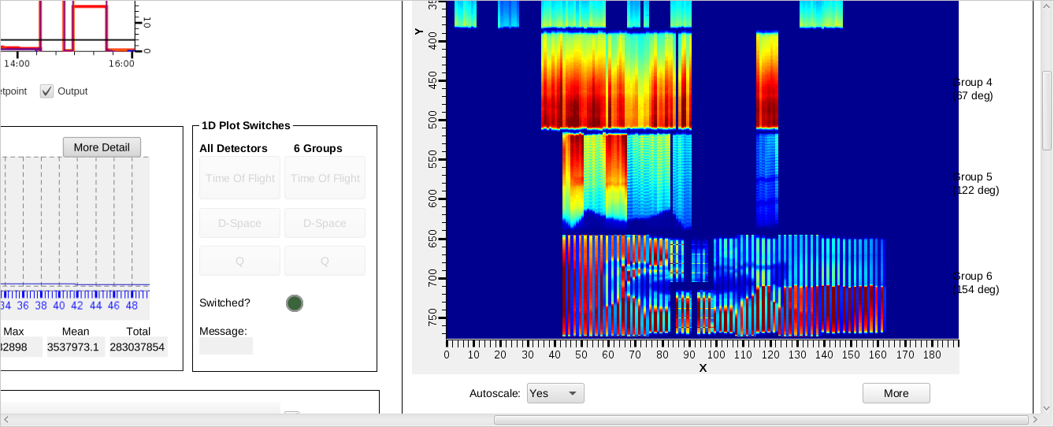

Figure 6. Right column of the dashboard, showing 2D plots of detectors and beam monitor data.



Figure 7. Graph Toolbar, with the Configure Settings, Perform Autoscale and Rubberband Zoom buttons highlighted (left to right).

Additional Screens

Additional screens (Figure 8) are available on the left monitor of the das-opi control computer with more instrument controls information. The Navigator pane on the extreme left displays the file structure. Files may be opened from the Navigator pane by double-clicking. To the right of the Navigator pane is the section containing several tabs with more information about the beamline equipment, along with the Scan Monitor pane at the bottom. The BL-1B NOMAD tab has indicator lights for the status of each piece of beamline equipment. All status lights should be green when functioning properly. The Table Scan tab contains table scan controls as will be described in detail below (Figure 9). The BL1B_User_Start_Page tab allows users to start and stop data acquisition manually. The BL1B_SKF_Choppers tab shows status lights for each of the three bandwidth choppers, along with the frequency and phase settings. The Cryostream tab shows the status of the sample changer (Shifter). The Furnace tab shows the temperature controls and plots, as in the Dashboard (Figure 4). Other tabs may be present depending on the sample environment equipment installed at the beamline.

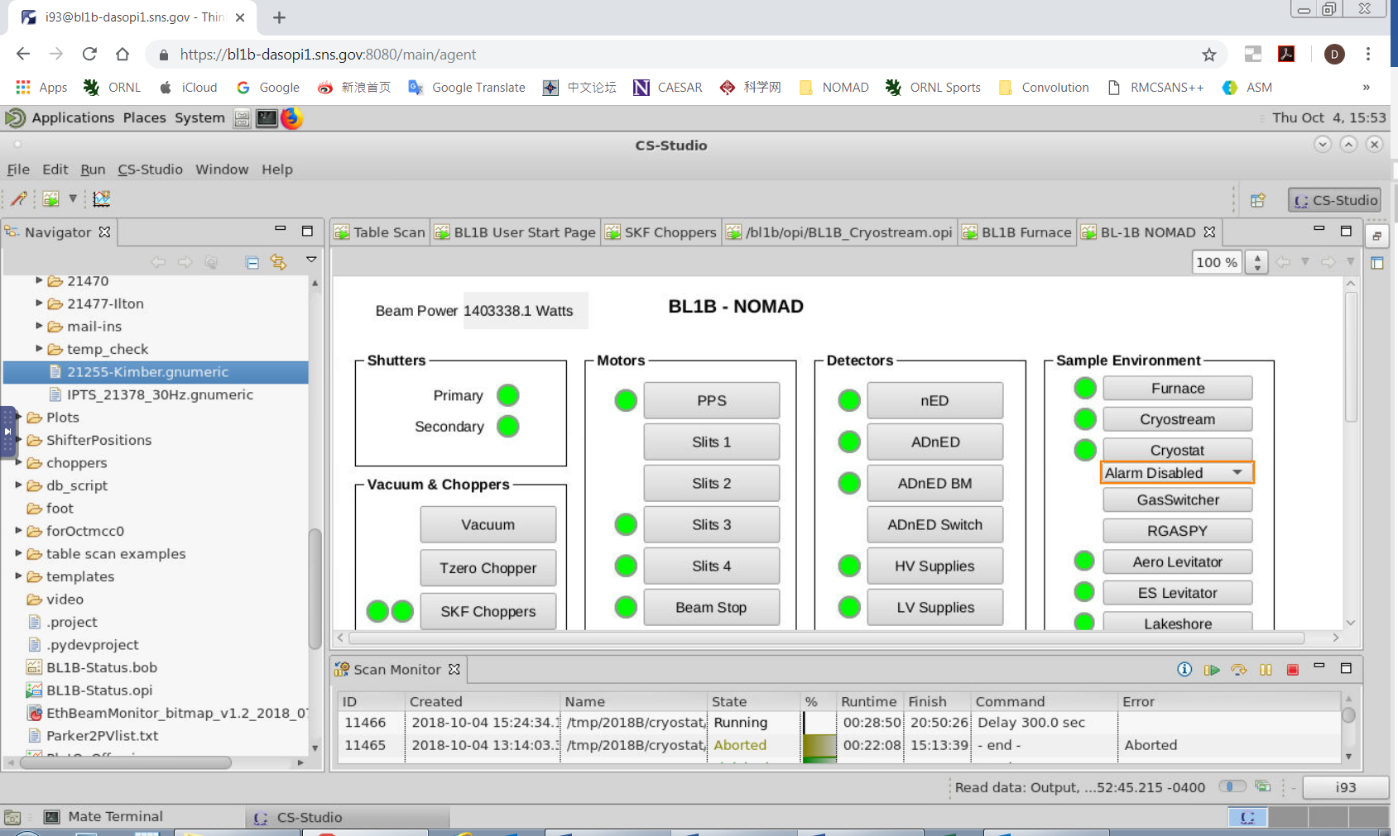

Figure 8. Additional screens shown on the left monitor of the control computer, showing controls of beamline equipment.

Table Scan Scripts

The preferred mode of data collection is using table scans (Figure 9), which are spreadsheet files that lay out the desired data collection and instrument steps, e.g. count time, sample temperature and sample changer position. User table scans are saved in the folder temp/cycle/SE/IPTS-XXXXX, where cycle is the run cycle (e.g. 2018B), SE is the sample environment (e.g. shifter) and XXXXX is the proposal number. Example scripts for each instrument setup are in the temp/cycle/SE/example_scripts folder. They may be opened and changed with the Gnumeric program.

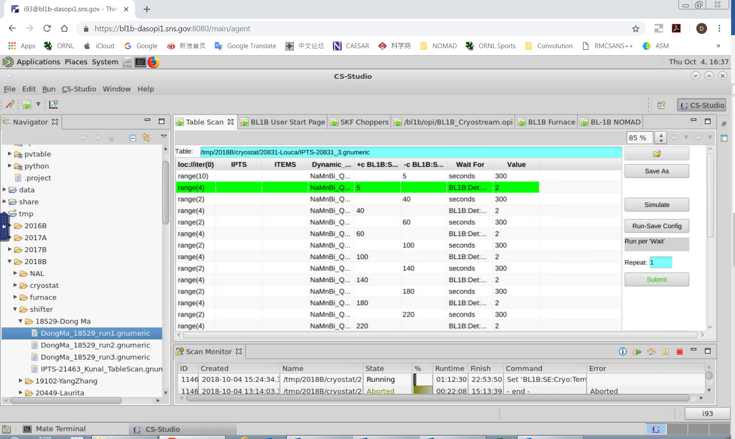

Figure 9. Additional screens shown on the left monitor of the control computer, showing table scan controls.

*Preparing a Script* To prepare a table scan, copy the appropriate example script into your proposal folder and rename it appropriately. Open the script in Gnumeric and replace the example values with your desired values. Each line contains the instrument and data collection parameters for one scan (or one set of similar scans). Table 1 describes the meaning of each column heading. Each line of the table will be executed successively.

Table 1. Table scan script column headings.

|  |  |
| --- | --- |
| Column Heading | Description |
| General Settings | |
| Dynamic_name | title for the run |
| ITEMS | Sample ID |
| IPTS | your proposal number |
| range(x) | repeat this line for x times |
| Loc://counter(0) | counter |
| Wait For | criteria to use to signal the end of the run, typically BL1B:Det:PCharge:C, or seconds |
| Value | value of criteria to signal the end the run |
| Shifter Sample Changer Settings | |
| sample | sample position (1-10) to load |
| +c temp_SHIFT | sample temperature in K, waits for completion of temp change to start collecting data (collect while at temp) |
| -c temp_SHIFT | sample temperature in K, does not wait for completion to collect data (collect during ramping) |
| Orange Cryostat Settings | |
| +c BL1B:SE:Cryo:TempsetpointSet | sample temperature in K, collect while at temp |
| -c BL1B:SE:Cryo:TempsetpointSet | sample temperature in K, collect during ramping |
| Furnace Settings | |
| +c BL1B:SE:ND1:Loop1:SP:SPSet | sample temperature in °C, collect while at temp |
| -c BL1B:SE:ND1:Loop1:SP:SPSet | sample temperature in °C, collect during ramping |
| BL1B:SE:ND1:Loop1:SP:RateSet | ramp rate in °C /min |

Data is typically collected either for a specified time or a specified cumulative beam power (known as pCharge). At NOMAD, we routinely collect on pCharge. When collecting on pCharge, data collection time will be extended if the neutron beam goes down during a run, in order to reach the same beam exposure. The expected amount of pCharge collected in one hour depends on the beam power, as in Table 2.

Table 2. Accumulated beam per hour, as a function of beam power.

|  |  |
| --- | --- |
| **Beam Power (MW)** | **pCharge per hour (coulomb/hr)** |
| 0.850 | 3.3 |
| 1.0 | 3.7 |
| 1.1 | 4.3 |
| 1.2 | 4.5 |
| 1.3 | 4.7 |
| 1.4 | 5.4 |

*Simulation* Once your table scan file is prepared, you may simulate it. The program will run through the script, line-by-line, without actually changing any parameters, and estimate the total time. To simulate a script, it must first be loaded into the EPICS software. On the Table Scan pane (Figure 9), click on the folder icon. Browse to and select your file. Once the correct path and filename are displayed to the left of the folder button, press the Load button. The table below should be filled with the entries from your script. Finally, press the Simulate button. On the left monitor, in-between the Navigator pane and the Table Scan pane, the simulation output will be displayed. Each change of an instrument setting will be outlined, along with the estimated time to execute each line of the script, and at the bottom, the total estimated time to execute the entire script. Check the simulation output carefully to ensure that everything is as expected.

*Submitting a Script* Once your script is ready and the simulation output has been verified, you may run your script by pressing the Submit button (Figure 9). A line will be added to the top of the Scan Monitor pane (Figure 8), representing that script. The Scan Monitor shows the filename, status (Aborted, Failed, Finished or Running), runtime, estimated finish time and which command is currently executing. Double clicking a script in the Scan Monitor pane displays the Scan Editor, which shows the list of commands to be executed, with the current command highlighted in green text.

Separate table scan scripts may be queued. While the first script is running, load and submit the second script. It will be added to the top of the Scan Monitor pane and will automatically be executed once the first script finishes.

To abort a currently running script, you may press the Abort button on the Scan Monitor Pane (Figure 8), which looks like a red square. You may also pause and resume a currently running script by pressing the appropriate buttons on the Scan Monitor Pane.